**EE 493**

**Mid-Semester**

**B. Tech Project Report**

**On**

**FULL DUPLEX ANTENNA**

By

Ajmeera Manusri

Ee200002004

Applied Electromagnetics Laboratory

**Project Supervisor: Dr. Saptarshi Ghosh**



1. Introduction

The demand for higher data rates and more efficient use of frequency bands in wireless communication systems has made the development of full-duplex antennas indispensable. The need for increased data rates and optimal frequency band utilization proliferates in today’s wireless communication landscape. Full-duplex antennas have emerged as a promising solution to address these pressing challenges by enabling simultaneous signal transmission and reception on the same frequency channel. This technology can potentially double data throughput compared to traditional half-duplex setups. Full-duplex antennas offer numerous advantages in wireless communication and networking. Their unique ability to transmit and receive signals simultaneously on the same frequency channel results in several significant benefits. These advantages include enhanced spectral efficiency, reduced communication latency, and improved data throughput. Consequently, full-duplex technology enables more efficient use of the available radio spectrum, simplifies network designs, and enhances reliability, especially in complex signal environments. In real-time communication applications like voice and video calls, full-duplex ensures consistent and dependable quality of service. Moreover, it promotes energy efficiency and provides the flexibility to optimize frequency resources, making it an indispensable asset in our evolving world of wireless communication systems. Full-duplex antennas find applications across various industries, including satellite communication, military operations, maritime navigation, aerospace systems, and wireless communication scenarios. The specific use of full-duplex antennas depends on factors such as range, bandwidth requirements, latency constraints, and interference conditions. As technology advances, full-duplex antennas are poised to find even more diverse applications across different sectors and industries. However, the main practical challenge in implementing full-duplex communication is managing the strong self-interference signal generated by the transmitter antenna at the receiver antenna within the same transceiver [1]. Effectively suppressing this self-interference signal is crucial to maintain system performance. Various techniques have been developed to address this challenge, including analog cancellation, digital cancellation, and antenna isolation methods such as adaptive cancellation, beamforming, and frequency separation. One efficient approach to mitigating self-interference in full-duplex antennas is antenna cancellation, which leverages the spatial characteristics of the antennas to reduce self-interference at the receiver antenna.

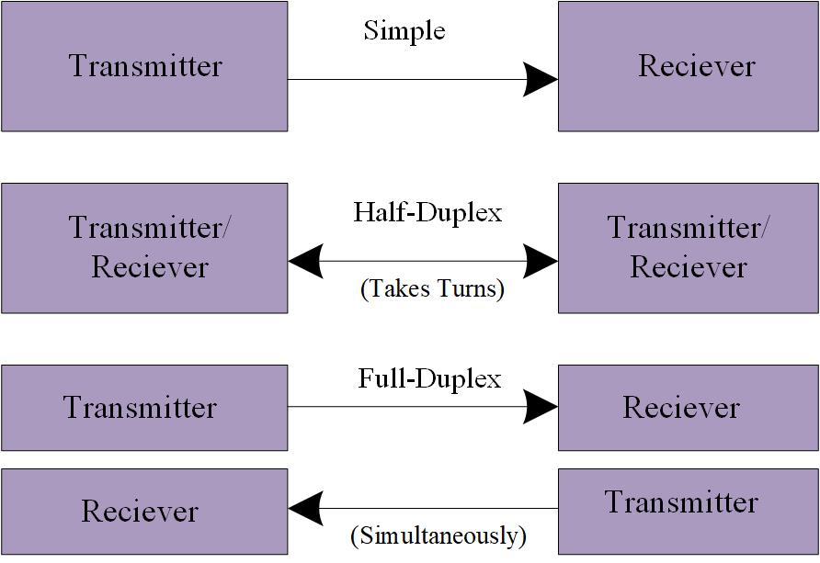

Fig (1): Definition of Full Duplex Antenna.

1. Literature Review

Full-duplex communication has garnered substantial attention and interest in academic and industrial circles. Reports indicate that full-duplex technology finds extensive applications in fifth-generation wireless networks and emerging satellite communications. Recent advancements in self-interference mitigation techniques have rendered full-duplex transmission more practical and feasible, overcoming previous concerns tied to self-interference issues. Previously deemed unworkable due to self-interference challenges, full-duplex transmission has recently become a focal point of research thanks to breakthroughs in self-interference cancellation methods. One approach highlighted in these sources involves leveraging multiple antennas to filter out self-interference signals, thus enhancing system performance spatially. Another mentioned technique combines analog and digital cancellation methods to reduce self-interference to the noise floor. Additionally, these sources reference two analog/RF designs that circumvent the need for bulky components and conventional antenna structures, offering a more streamlined and efficient solution for self-interference mitigation in full-duplex systems. In full-duplex systems, a pressing challenge arises from the co-location of transmitting and receiving antennas, known as RF self-interference. RF self-interference occurs when the high-power transmitted signal interferes with the weaker received signal within the same frequency band. This interference can degrade signal quality and harm overall system performance. The progress made in self-interference cancellation techniques plays a pivotal role in addressing this challenge and rendering full-duplex transmission more viable. Numerous methods and strategies have been proposed to alleviate RF self-interference in full-duplex systems.

In [2]-[3], Specially designed structures called Electromagnetic Bandgap Structures (EBG) have been used to prevent specific frequencies from propagating. They are used to isolate antennas, ensuring that unwanted electromagnetic waves do not interfere with the desired signal. In [4]-[6], A neutralization line is used, a component connected to an antenna to balance its electrical characteristics, minimizing self-interference by canceling undesirable signals. The neutralization line cancels out the part of the transmit signal that can leak into the receiver through common ground and other coupling paths. This can decrease self-interference, meaning the transmitter and receiver can function more effectively without distorting each other's signals. In [7][8], Defected Ground Structures (DGS) are used, which involve patterns etched into a ground plane to modify electromagnetic properties. They help suppress unwanted radiation from a printed circuit board, reducing interference. DGS works by introducing a defect or break in the ground plane of the microstrip antenna layout. This defect can modify the current distribution and change the transmission characteristics of the antenna system. In [9][10], Absorbers are used; these are the materials that absorb electromagnetic waves. Placing them strategically between antennas can prevent reflections and interference, improving antenna performance. They absorb and dissipate the unwanted electromagnetic energy, preventing it from bouncing back into the antenna and causing interference. This selective absorption helps ensure that the antenna can transmit and receive signals without the disruptive effects of self-interference.

It can be challenging to achieve strong isolation between transmit and receive channels, especially in compact designs, which raises the complexity and cost of the system. Additionally, neighboring devices may cause interference for FDAs, and simultaneous operations may increase power consumption. To maximise FDA benefits, careful engineering and design are essential.

1. Objective
2. The primary goal of this project is to create an advanced microstrip patch antenna system that is finely tuned for optimal performance in full-duplex (FD) and multiple-input, multiple-output (MIMO) applications.
3. To achieve outstanding performance in terms of inter-port isolation, impedance matching, and radiation efficiency, all centered around the 5.85 GHz frequency.
4. To address the challenges and limitations associated with full-duplex antennas (FDAs), focusing on enhancing isolation, minimizing interference, optimizing power efficiency, and ensuring efficient simultaneous operation in compact designs.
5. In addition to these goals, the project aims to push the boundaries of antenna design by exploring innovative strategies, such as integrating defected ground structures (DGS) and complementary DGS (CDGS), to enhance the antenna’s isolation capabilities.
6. The overarching objective is to create an antenna system that is exceptionally well-suited for the evolving landscape of wireless communication technologies, including but not limited to 5G NR-U. This will be demonstrated through superior self-interference cancellation capabilities and robust MIMO communication performance.
7. Antenna Design

A microstrip patch antenna has a simple design comprising two metallic layers separated by a dielectric substrate. The upper metallic layer is the radiating patch, while the lower layer is the ground plane. Typically, copper is preferred for the metallic layer, though occasionally gold may also find application. The patch itself can assume diverse shapes, including rectangular, triangular, circular, square, dipole, or elliptical. The selection of the patch’s shape depends on factors like ease of fabrication and the capacity to assess and anticipate the antenna’s performance accurately. When it comes to constructing microstrip antennas, a range of dielectric materials are available, each possessing a dielectric constant within the interval of 2.2 to 12. Crucially, the substrate thickness, often referred to as the dielectric thickness, plays a pivotal role in defining the antenna’s characteristics. Below are the formulas used to calculate the patch parameters:

|  |  |
| --- | --- |
| Width of the patch (Wp) |  |
| Length of the patch (Lp) |  |
| Width of the Substrate (Wg) |  |
| Length of the Substrate (Lg) |  |
| Width of the Feed (Wf) |  |
| Length of the Feed (Lf) |  |

Table (1): Formulae of a simple microstrip patch antenna.

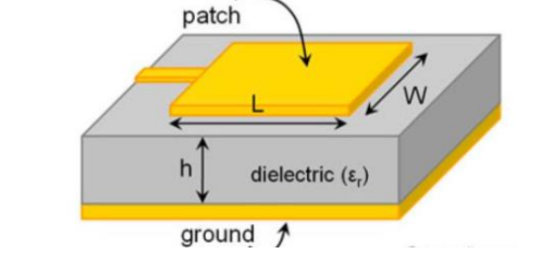

Fig (2): Basic diagram of a Microstrip Patch antenna [10]

To characterize the antenna structure, a coaxial feeding method is employed, which is a non-planar feeding technique. In this approach, the outer conductor of the coaxial cable is grounded, while the inner core of the cable is directly soldered to the antenna patch. The core conductor is inserted into a hole in the substrate. This feeding technique offers a significant advantage in that it enables the inner conductor to be directly connected to the feed point, where the input impedance matches the characteristic impedance of the feed line. Furthermore, the presence of the ground plane serves to segregate undesired radiation from both the feed and antenna radiation, thereby enhancing the overall radiation performance.

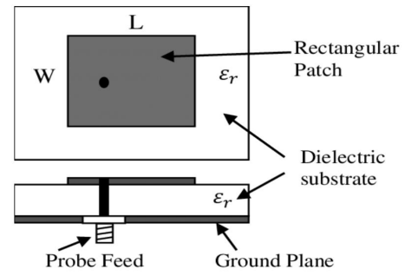

Fig 3: Coaxial fed patch antenna [11].

* Stage 1

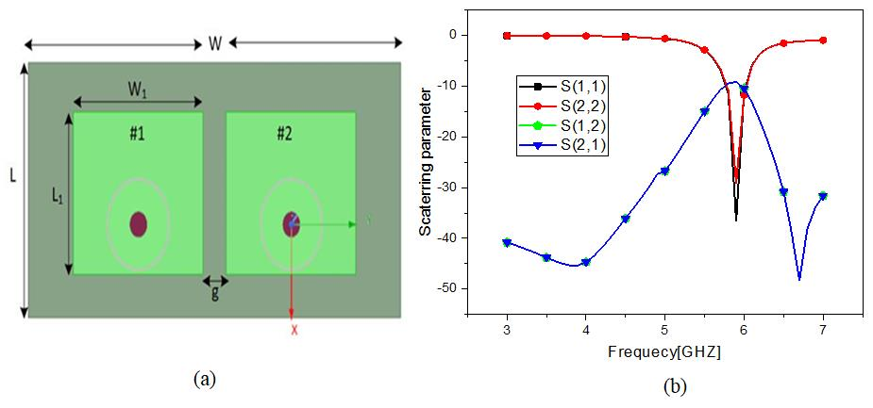

Fig 4 (a): Top view of the proposed antenna at Stage 1. L = 23.62mm, W = 50.68mm, L1 = 15mm, W1 = 17.65mm, g = 3.17. (b) S- parameter response of the antenna.

In stage 1, two symmetrical microstrip patch antennas with dimensions length (L1) = 15mm and width (W1) = 17.65 mm are positioned at a separation distance (g) of 3.17 mm on a substrate measuring length (L) = 23.62 mm and width (W) = 50.68 mm. The microstrip patch antenna is fabricated using a 1.57 mm thick RTD5880 substrate with εr = 2.2 and tan δ = 0.0009. This simple design employs coaxial feeding and is intended to operate within the 5.85 GHz LTE band. Figure 4 (b) illustrates that the impedance matching is excellent, as indicated by (|S11| < -10 dB), but isolation between antenna elements is poor. This outcome is achieved by actively exciting port one while terminating port two. Figure 3 (c) showcases a low cross-polarization level between the E and H fields, radiating in a broadside direction.

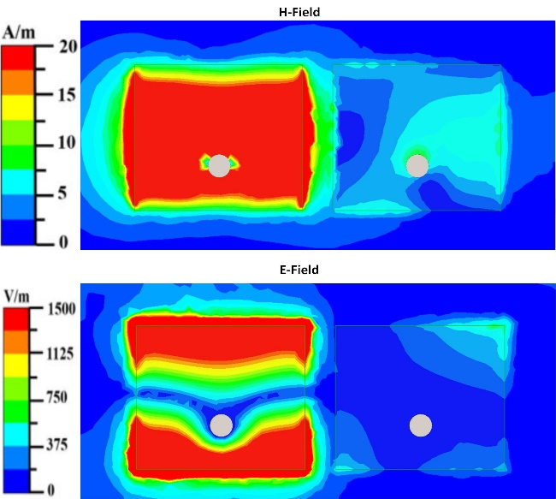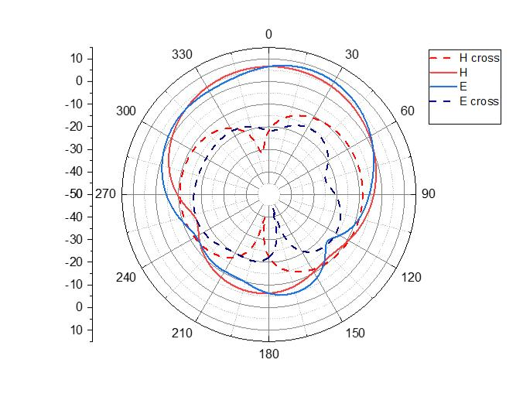

Fig (4c): E field distribution on the patches at stage 1, along with simulated 2D Radiation pattern of the proposed antenna. (port 1 is activated, keeping the port 2 terminated)

* Stage 2

At this juncture, an L-shaped structure to both microstrip patches is introduced to induce asymmetry. The L-shaped construction elongates the effective electrical length of each antenna element. This L-shaped addition results in a shift of the operating frequency from 5.89 to 6 GHz. Furthermore, compared to the first stage, mutual coupling is further reduced. The width of the L-shaped structure measures 0.75mm, and detailed configurations of these proposed structures are shown in Figure 5a. While the individual antenna impedance matching may be affected by the asymmetry in the antenna design.Figure 5b illustrates that E-field coupling still persists, as seen in the 2D radiation pattern of the stage-1 antenna configuration.

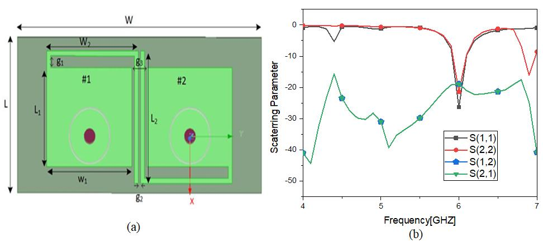

Fig 5(a): Top view and the scattering parameter of the antenna. Dimensions: L = 14.45, W = 50.68, L1 = 15, W1 = 17.65, L2 = 20.14, W2 = 18.96, g1 = 1.90, g2 = 0.5, g3 = 3.17 (unit mm). (b) S parameter response of the antenna.

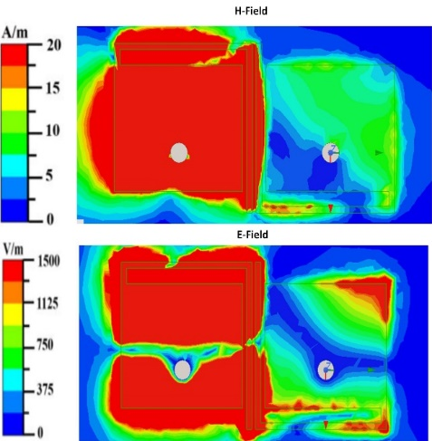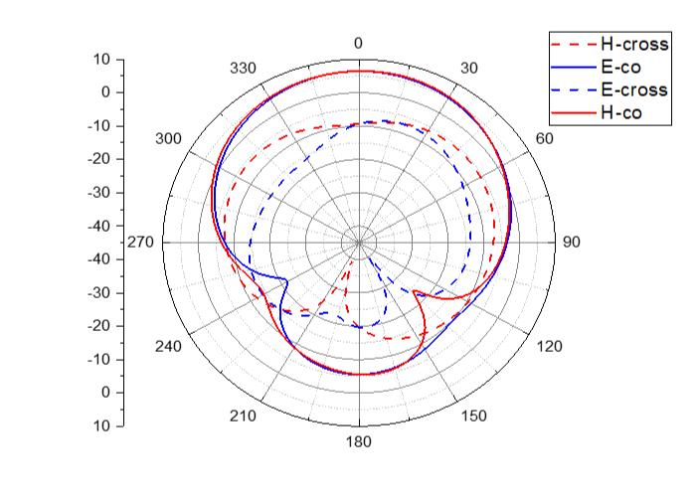

Fig (5c): E-field distribution on the microstrip patches at stage 2, along with simulated 2D Radiation pattern of the proposed antenna. (port one is activated, keeping the port two terminated)

* Stage 3

A DGS (Distorted Ground Structure) of length ld = 20mm and width wd = 20mm has been etched in the ground. The graph depicts that there still is some mutual coupling between them. Fig (6) depicts the scattering frequency of the proposed antenna.

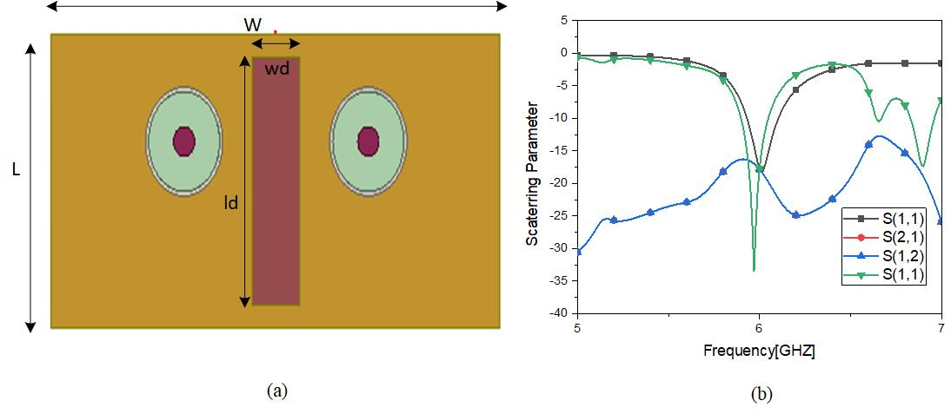

Fig (6): Bottom view and the variation of the scattering parameter of the antenna at stage 3(all parameters are in mm) L = 50, w = 50.68, wd = 5.42, ld = 22.28.

* Stage 4

At this stage, another substrate of RTD5880 substrate with εr = 2.2, tan δ = 0.0009, and a thickness of 0.5mm is used. This layer is kept apart from the first substrate layer with a distance of 0.63mm. Two NFDS (Near-Field Distorted Structure) of length Ls = 22.28mm and Width Ws = 0.84 mm are mounted on this substrate layer.

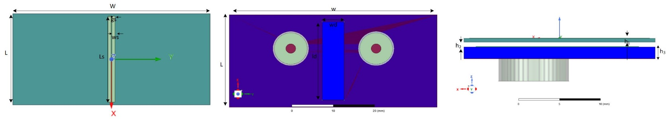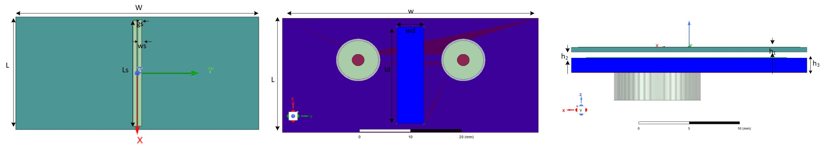

Fig (7): Top and side view of the antenna at stage 4. (all parameters are in mm). L = 50, W = 50.68, Ls = 22.28, Ws = 0.84, gs = 0.20, h3 = 1.57, h2 = 0.7, h1 = 0.5.

The dimension of the DGS determines the stop band effect by incorporating transmission zero at the frequency of interest. DGS loading in the ground plane minimizes the surface wave excitation, increasing the cross-polar response. The phase of the partially diffracted wave that cancels out the linked wave depends on the distance between the NFDS and the antenna ground plane. The height between the defective ground and the NFDS also guarantees a very low inter-element mutual coupling value. The length and width of the DGS and NFDS will be carefully decided by doing a parametric analysis of each element. Table (2) shows the mutual coupling at different stages. At every subsequent stage the isolation has increased.

|  |  |  |
| --- | --- | --- |
| Stages | Impedance Matching (S11, S22) | Isolation |
| 1 | -30, -38 | -10 |
| 2 | -25, -28 | -15 |
| 3 | -18, -35 | -18 |

Table (2): Impedance matching and Isolation at different stages.

Future Work:

1. Designing of a full-duplex antenna with very high degree of isolation.
2. Enhancing antenna gain and directivity to boost signal strength and communication precision.
3. Following the completion of design modifications, fabricating the antenna structure.
4. Thoroughly testing the fabricated antenna, involving comprehensive data collection and in-depth analysis.
5. Validating the design by meticulously comparing the test results with simulated outcomes, facilitating necessary adjustments and fine-tuning.

References:

1. Koohian, A., Mehrpouyan, H., Nasir, A.A. et al., “Superimposed signaling inspired channel estimation in full-duplex systems,” *EURASIP J. Adv. Signal Process*. 2018.
2. C. D. Nwankwo, L. Zhang, A. Quddus, M. A. Imran and R. Tafazolli, “A Survey of Self-Interference Management Techniques for Single Frequency Full-Duplex Systems,” *IEEE Access,* vol. 6, pp. 30242-30268, 2018.
3. Sandi E, Maruddani B, Yuliatmojo P, Saputra AA. “Design of Uniplanar Compact Electromagnetic Band Gap (UC-EBG) for Massive MIMO 5G C-Band Antenna.” *Research Square,*2023.
4. Kumari, K, Jaiswal, RK, Srivastava, KV, “An in-band full-duplex antenna for dual-band application,” *Microw Opt Technol Lett. 2022.*
5. Ahmed, E.A.E. (n.d). “Self-interference Cancellation in Full-duplex Wireless Systems.”
6. M. Li, L. Jiang, and K. L. Yeung, "A General and Systematic Method to Design Neutralization Lines for Isolation Enhancement in MIMO Antenna Arrays,” *IEEE Transactions on Vehicular Technology*, vol. 69, no. 6, pp. 6242-6253, June 2020,
7. Yashvanth, L., Dharanya, V., & Gopi, E.S. (Date). “Novel Method of Self-interference Cancelation in Full-Duplex Radios for 5G Wireless Technology Using Neural Networks”.
8. Verma, M.K., Kanaujia, B.K., Saini, J.P., & Singh, P. (Year). “A Compact Multi-Slots Loaded Gap Coupled CP Antenna with DGS for WLAN/WiMAX Applications”.
9. Maojun Li,Wei Zhang, “Design of a multilayer wideband absorber basedon frequency selective surface”*, Optical and Quantum Electronics (2023)*
10. Bhagat, N., & Jain, P. “Microstrip Patch Antenna with Circular Slot for Wireless Applications”, vol2, Issue1, 2016.
11. Jaget Singh et al 2021 IOP Conf. Ser.: Mater. Sci. Eng. 1033 012039